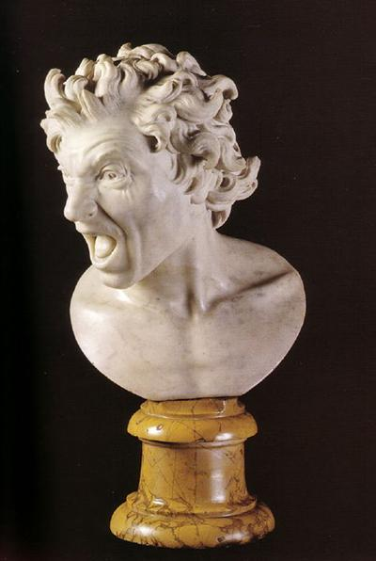

Damned Soul, Gian Lorenzo Bernini, 1619, Palazzo di Spagna, Rome, Italy

What were up to when you were twenty?

I was trying to figure out how to talk to a girl without revealing that I was a clueless goon.

Gian Lorenzo Bernini was obsessed with proving his genius to the world.

He succeeded.

(The jury is still out on me).

Gio succeeded first with a project that involved not one, but two works.

Works that were polar opposites of each other.

Works that represented the physical manifestations of the fork in the road we all inevitably take; the road that leads either to the express elevator up. Or the express elevator down.

To Heaven. Or Damnation.

Sort of a good news, bad news thing.

Let’s start with the bad news: the express elevator to the basement.

In the sculpture of his Damned Soul (above), Bernini crafts a portrait of a soul who is in the midst of realizing his fate.

The news isn’t good. As the title indicates, he is damned, as in damned to hell, as in about to cross over to the other side of the River Styx. As in for eternity.

And it seems as though the news is just sinking in.

Because he seems, well, a tad displeased.

The young Bernini sculpted this and its companion work (which we’ll get to in a moment) as a personal challenge- he wanted to see if he was up to the task of crafting the ultimate bookends of emotion.

He was.

And, in the process, the youngster revealed a few things about himself.

Because for the Damned Soul he chose a man (as opposed to a woman; see below). A man with clear features- a thick brow, a twisted mustache and a head full of wavy hair consumed in a wild expression, twisted in shock and horror.

A man who seems to be having trouble digesting his fate.

And he did not choose just any man.

He chose himself.

That is the young Bernini we are looking at.

(Guilty conscience Gio?).

As the well documented story goes, Bernini intentionally and repeatedly stabbed himself with a small dagger- trying to inflict maximum agony- while at the same time looking in the mirror, attempting to capture a look of pain and horror that might approximate the feeling you’d have if you just got the news that you needed to press the down button.

He seems to have succeeded.

As it is his first masterpiece- in a long line of masterpieces.

Now, to end on a more optimistic note, let’s move to his other work- and the good news.

To a work where the subject is not looking downward toward the fiery furnace. But one, called the Blessed Soul (below), which serenely looks skyward to her destination of bliss.

And for the Blessed Soul, Bernini, as earlier intimated, chose a woman- quite a statement for the time (when women were thought not just to be the weaker sex but inherently inferior). Bernini deciding to show “chattel” as closer to God than a man caused quite the stir.

It was a daring move for a relatively unknown twenty year old.

But back to the woman who’s about to take her final ride to the top.

The Blessed Soul looks heavenward, almost as though she is listening to angelic music, her hair adorned with a garland of roses. Between her ecstatic parted lips, we detect a row of perfect teeth- a flourish that Bernini added to make an additional point (as the ancients regarded sculpting teeth as proof of a consummate sculptor- and Gio, intent on making a name for himself, was not about to lag behind the Greeks and the Romans). While the figure lacks a sense of personality- that is by design, as that is his point. Bernini is telling us that she has been purified by her faith.

It is a work of innocence, a portrait of a beautiful, accepting woman in unconditional joy- contrasting perfectly with his Damned Soul.

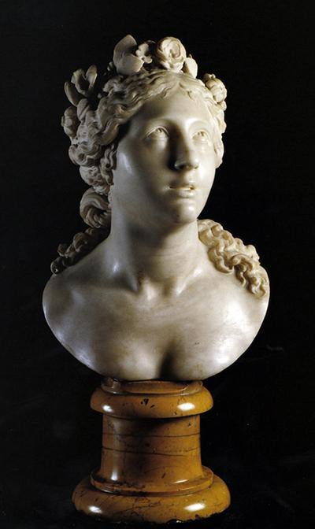

Blessed Soul, Gian Lorenzo Bernini, 1619, Palazzo di Spagna, Rome, Italy

A few tidbits:

Let’s not forget, the guy was twenty at the time.

20!

In making his imaginative leap into the extremes of Paradise and the Inferno, Bernini appears to have relied on the Spiritual Exercises of Ignatius Loyola as a guide (the rise of the Jesuits coincided with both the Counter Reformation and the rise of Bernini). In his exercises- which were designed to allow people to discern between a good spirit and a bad spirit- Loyola wrote about how all humans are constantly pushed and pulled in two directions: toward goodness and toward sin- and how you can tell by a person’s features which way they are leaning

While his Damned Soul was well received, ironically, his Blessed Soul was not without its critics- as many experts called it uninspiring- especially when compared to the Damned Soul (which I get). One critic explained it away by saying that being virtuous did not translate well into marble. While another went so far as to say that Bernini’s treatment of her hair was amateurish- describing it as doughy (which I don’t get).

But everyone’s a critic.